Assessment: Assignment 3

Student Name:

Lab Professor Name:

Lab Section Number:

Due Date:

# Understand the problem

This program will calculate if the cube that we just produce is close to perfect shape, the deference between height, length and width is with 0.1 deference. At end of the program, you have the option to print the report of how many good cubes and bad ones with the percentage of each

# Pseudocode

Class metal cube program

Start

Declare integer ENTER_DATA =1;

Declare integer REPORT =2;

Declare integer EXIT =0;

Declare class MetalCubeAnalyzer analyzer ;

Declare class UserInput input;

Declare Boolean loop=true;

While loop=true

Print “Please enter 1 to add cube diminution”

Print “please enter 2 for report of the cube”

Print “please enter 0 to exit the report”

Case based on input

Case = ENTER_DATA

Use analayzer to enter dimension

Case = REPORT

Use analyzer to print report of good cubes and bad cubes

Case = EXIT

Exit the program and loop

Loop=false

Default

Print “the number that has been selected in incorrect please enter again”

End case

End while

End

Start UserInput;

Declare scanner;

Function double input Double

{

While input is not double

Scan next line

Print Number entered is not double please enter again

End while

Declare double result =new input

Return result

}

Function int inputInteger

{

While input is not integer

Scan next line

Print Number entered is not integer please enter again

End while

Declare int result =new input

Return result

}

End

Start MetalCube

Declare private double length, width , height;

Delare private double cubesize=10;

Declare private double EPSILON=0.1;

Constructor Public MetalCube

{

Length=10;

Width=10;

Height=10;

}

Constructor Public MetalCube (declare double length, declare double width, declare double height)

{

Function setLength(length);

Function setWidth(width);

Function setHeight(height);

}

Function public double getLength

Return length

Function public setLength(declare double length)

length=length

Function public double getWidth

Return width

Function public setWidth (declare double width)

width = width

Function public double getHeight

Return height

Function public setHeight (declare double height)

height = height

function public Boolean isWithinTolerance

{

declare double d1,d2,d3;

declare boolean result=true;

d1=abstract of(width-height)

d2=abstract of(height-length)

d3=abstract of(width-length)

if (d1<= EPSILON and d2 <= EPSILON and d3 <= EPSILON)

result =true;

else

result = false;

return result;

}

End

Start MetalCubeAnalyzer

Declare Private int countGoodCubes;

Declare Private int countBadCubes;

Declare class UserInput input;

Funcation public entercube

{

Declare class metalcube cube;

Output “Please enter hight of the cube”

class cube set height(input double)

print “Please enter width of the cube”

class cube set Width (input double)

print “Please enter length of the cube”

class cube set Length (input double)

if cube set isWithinTolerance

countGoodCubes= countGoodCubes+1;

else

countBadCubes= countBadCubes+1

}

Function printReport

{

Declare double sum, GoodPercent, BadPercent

sum=countGoodCubes+countBadCubes;

GoodPercent=countGoodCubes/sum*100;

BadPercent=(countBadCubes/sum)*100;

Print “count of good cubes is:countGoodCubes”

Print “count of bad cubes is:countBadCubes”

Print “count of total cubes is: sum ”

Print “the percentage of the good cubes is: GoodPercent %”

Print “the percentage of the bad cubes is: BadPercent%”

}

End

# Flowchart

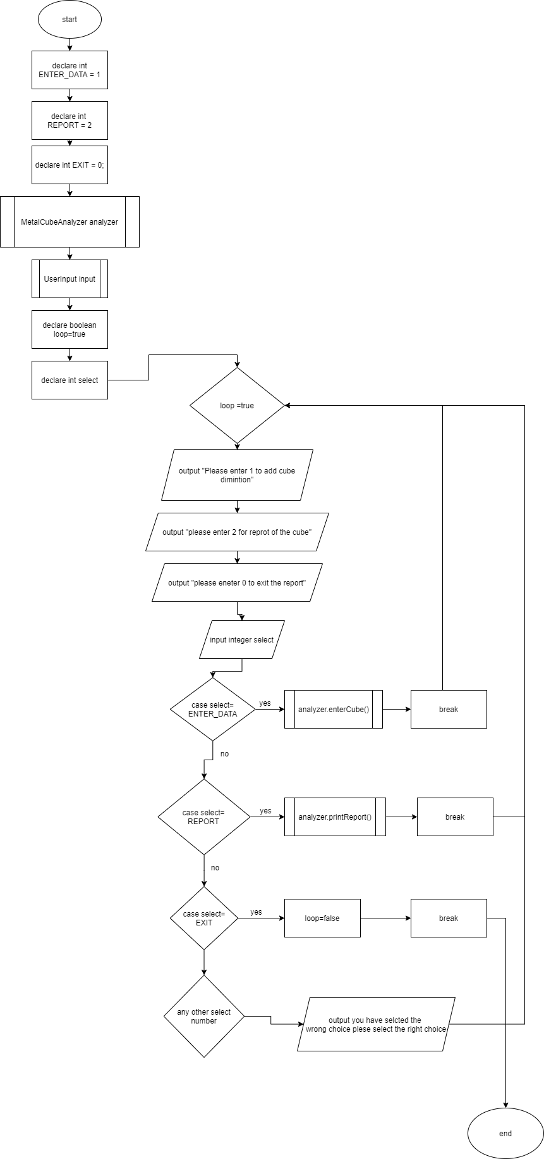

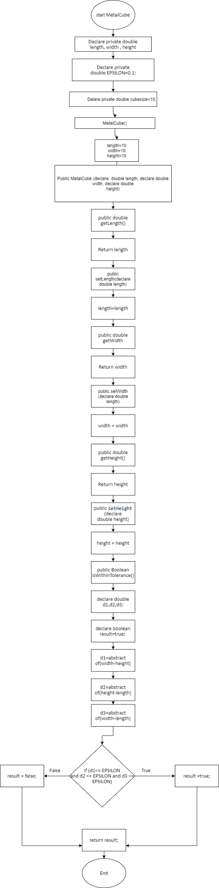

# 

# 

# UML

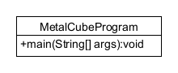

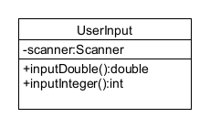

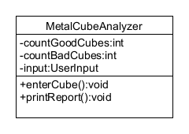

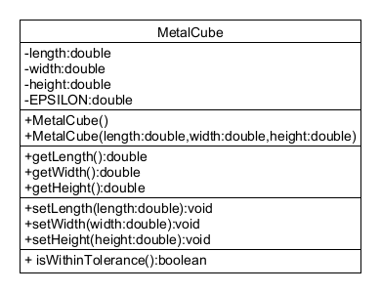

# Test Algorithm with Simple Input

|  |  |  |  |
| --- | --- | --- | --- |
| Input | Expected Output | Output | Description |
| 1  10,10,10  2 | Please enter 1 to add cube dimintion  please enter 2 for reprot of the cube  please eneter 0 to exit the report  Please enter height of the cube  Please enter width of the cube  Please enter length of the cube  Please enter 1 to add cube dimintion  please enter 2 for reprot of the cube  please eneter 0 to exit the report  count of good cubes is:0  count of bad cubes is:1  count of total cubes is:1.0  the percentage of the good cubes is:0.0%  the percentage of the bad cubes is:100.0%  Please enter 1 to add cube dimintion | Please enter 1 to add cube dimintion  please enter 2 for reprot of the cube  please eneter 0 to exit the report  Please enter 1 to add cube dimintion  please enter 2 for reprot of the cube  please eneter 0 to exit the report |  |
| 3 | Please enter 1 to add cube dimintion  please enter 2 for reprot of the cube  please eneter 0 to exit the report  you have selected the wrong choice please select the right choice | you have selcted the wrong choice plese select the right choice |  |
| 1  10,a,10,10  0 | Please enter 1 to add cube diminution  please enter 2 for reprot of the cube  please eneter 0 to exit the report  Please enter height of the cube  Please enter width of the cube  Number entered is not double please enter again  Please enter length of the cube |  |  |

# Compile and Run Your Program

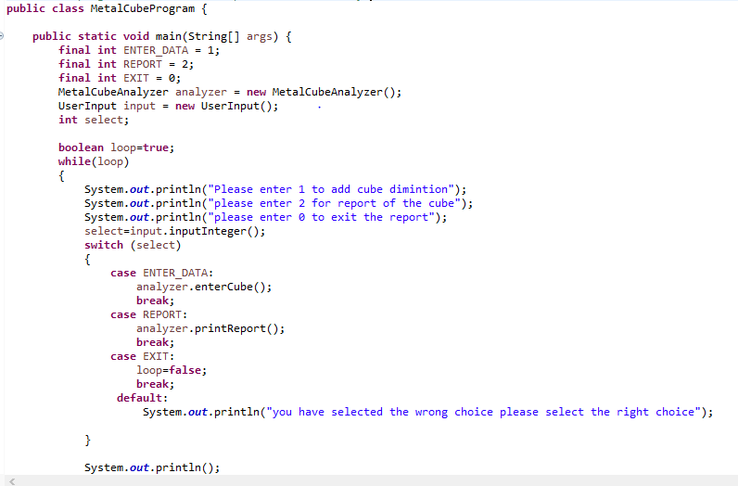

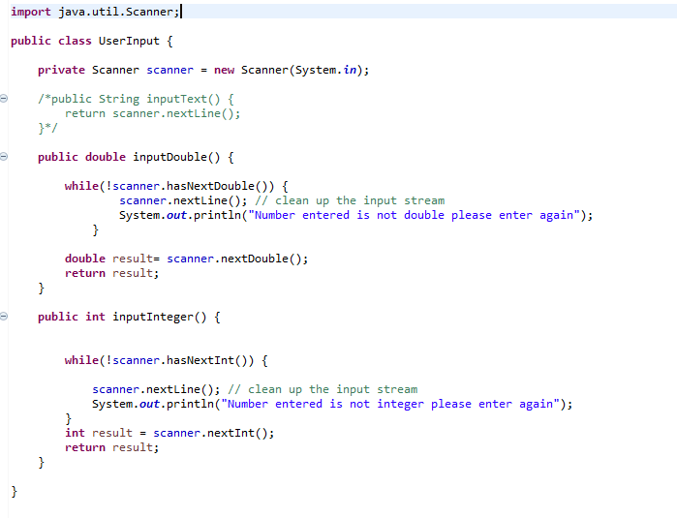

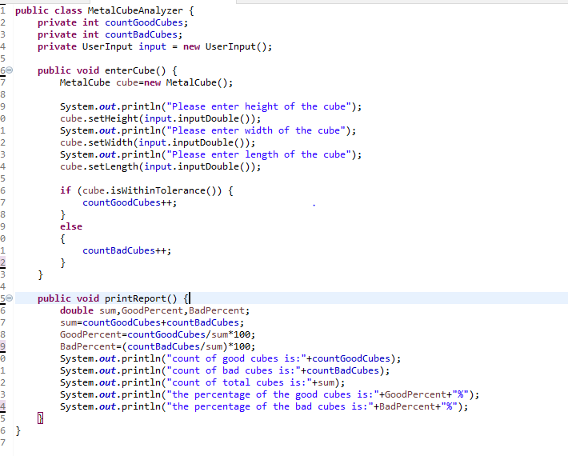

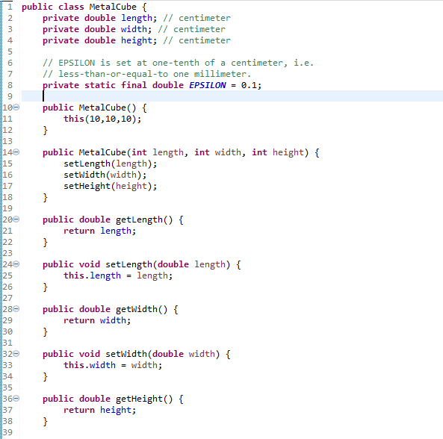

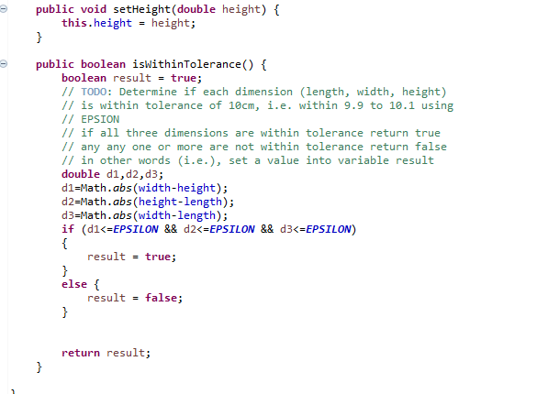

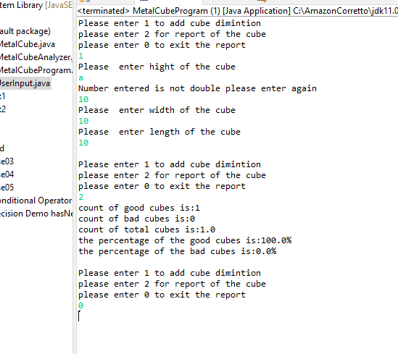

# Test Your Program

|  |  |  |  |
| --- | --- | --- | --- |
| Input | Expected Output | Output | Description |
| 1  10,10,10  2  0 | Please enter 1 to add cube dimension  please enter 2 for report of the cube  please enter 0 to exit the report  --  Please enter height of the cube  Please enter width of the cube  Please enter length of the cube  --  Please enter 1 to add cube dimension  please enter 2 for report of the cube  please enter 0 to exit the report  count of good cubes is:1  count of bad cubes is:0  count of total cubes is:1.0  the percentage of the good cubes is:100.0%  the percentage of the bad cubes is:0.0%  Please enter 1 to add cube dimension  please enter 2 for report of the cube  please enter 0 to exit the report  Thanks for using program  Programed by Programmer name | Please enter 1 to add cube dimension  please enter 2 for report of the cube  please enter 0 to exit the report  --  Please enter height of the cube  Please enter width of the cube  Please enter length of the cube  --  Please enter 1 to add cube dimension  please enter 2 for report of the cube  please enter 0 to exit the report  count of good cubes is:1  count of bad cubes is:0  count of total cubes is:1.0  the percentage of the good cubes is:100.0%  the percentage of the bad cubes is:0.0%  Please enter 1 to add cube dimension  please enter 2 for report of the cube  please enter 0 to exit the report  Thanks for using program  Programed by Programmer name |  |
| 1  A,3,3,4  2  0 | Please enter 1 to add cube dimension  please enter 2 for report of the cube  please enter 0 to exit the report  1  Please enter height of the cube  a  Number entered is not double please enter again  3  Please enter width of the cube  3  Please enter length of the cube  4  Please enter 1 to add cube dimension  please enter 2 for report of the cube  please enter 0 to exit the report  2  count of good cubes is:0  count of bad cubes is:1  count of total cubes is:1.0  the percentage of the good cubes is:0.0%  the percentage of the bad cubes is:100.0%  Please enter 1 to add cube dimension  please enter 2 for report of the cube  please enter 0 to exit the report  0  Thanks for using program  Programed by Programmer name | Please enter 1 to add cube dimension  please enter 2 for report of the cube  please enter 0 to exit the report  1  Please enter height of the cube  a  Number entered is not double please enter again  3  Please enter width of the cube  3  Please enter length of the cube  4  Please enter 1 to add cube dimension  please enter 2 for report of the cube  please enter 0 to exit the report  2  count of good cubes is:0  count of bad cubes is:1  count of total cubes is:1.0  the percentage of the good cubes is:0.0%  the percentage of the bad cubes is:100.0%  Please enter 1 to add cube dimension  please enter 2 for report of the cube  please enter 0 to exit the report  0  Thanks for using program  Programed by Programmer name | When the user enter |